CS266 Practice Lab 4

NAME:

ARCHIT AGRAWAL

ROLL NO. :

202051213

SECTION:

2

**Code 1**

//thread_example1.c

#include<stdio.h>

#include<pthread.h>

#include<unistd.h>

#include<sys/time.h>

//#include<sys/types.h>

void *kidfunc(void *p)

{

    printf("Thread ID is ---> %u\n",pthread_self());

    printf("Kid ID is ---> %d\n",getpid( ));

}

void main( )

{

    pthread_t kid;

    pthread_create(&kid, NULL, kidfunc, NULL);

    printf("Parent ID is ---> %d\n", getpid( ));

    //pthread_join(kid, NULL);

    printf("No more kid!\n");

    //return 0;

}

**Output**

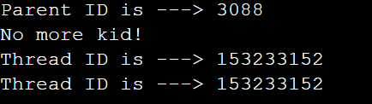



**Code 2**

#include <stdio.h>

#include <pthread.h>

int glob_data = 5 ;

void *kidfunc(void *p)

{

    printf ("Kid here. Global data was %d.\n", glob_data);

    glob_data = 15;

    printf("Kid Again. Global data was now %d.\n", glob_data);

}

int main( )

{

    pthread_t kid;

    pthread_create (&kid, NULL, kidfunc, NULL);

    printf("Parent here. Global data = %d\n",glob_data);

    pthread_join(kid,NULL) ;

    printf("End of program. Global data = %d\n", glob_data);

}

**Output**

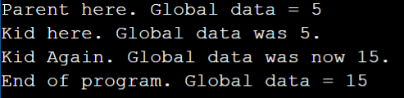

**Code 3**

#include<pthread.h>

#include<stdio.h>

//#include<sys/types.h>

//#include<unistd.h>

#include<stdlib.h>

int sum; /*This data is shared by the thread(s) */

void *runner(void *param); /* the thread */

void main(int argc, char *argv[]){

    pthread_t tid; /* the thread identifier */

    pthread_attr_t attr; /* set of thread attributes */

    if(argc != 2)

    {

        fprintf(stderr,"usage: a.out <integer value>\n");

        exit(0);

    }

    if(atoi(argv[1]) < 0)

    {

        fprintf(stderr, "%d must be >= 0 \n", atoi(argv[1]));

        exit(0);

    }

/* get the default attributes */

pthread_attr_init(&attr);

/*create the thread */

pthread_create(&tid,&attr,runner,argv[1]);

/* Now wait for the thread to exit */

pthread_join(tid,NULL);

printf("sum = %d\n",sum);

}

/*The thread will begin control in this function */

void *runner(void *param)

{

    int upper = atoi(param);

    int i;

    sum=0;

    if(upper > 0)

    {

        for(i=1; i <= upper;i++)

        sum += i;

    }

    pthread_exit(0);

}

**Output**



**Code 4**

#include<pthread.h>

#include<stdio.h>

#include<stdlib.h>

#include<sys/types.h>

#include<unistd.h>

#define NUM_THREADS 5

void *PrintHello(void *threadid)

{

    printf("\n%d: Hello World!\n", threadid);

    //pthread_exit(NULL);

}

int main( )

{

    pthread_t threads [NUM_THREADS];

    int rc, t;

    for(t=0; t < NUM_THREADS; t++)

    {

        printf ("Creating thread %d\n", t);

        rc = pthread_create (&threads[t], NULL, PrintHello, (void *) t );

        if (rc)

        {

            printf("ERROR; return code from pthread_create() is %d\n",rc);

            exit(-1);

    }

}

//pthread_exit(NULL);

}

**Output**

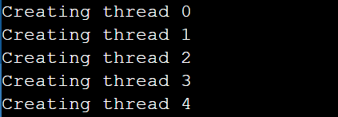

**Code 5**

//thread_example5.c

#include <stdio.h>

#include <pthread.h>

#include <unistd.h>

#include<stdlib.h>

int this_is_global;

void thread_func( void *ptr );

int main( )

{

    int local_main; int pid, status;

    pthread_t thread1, thread2;

    printf("First, we create two threads to see better what context they share...\n");

    this_is_global=1000;

    printf("Set this_is_global=%d\n",this_is_global);

    pthread_create( &thread1, NULL, (void*)&thread_func, (void*) NULL);

    pthread_create(&thread2, NULL, (void*)&thread_func, (void*) NULL);

    pthread_join(thread1, NULL); pthread_join(thread2, NULL);

    printf("After threads, this_is_global=%d\n",this_is_global);

    printf("\n");

    printf("Now that the threads are done, let's call fork..\n");

    local_main=17; this_is_global=17;

    printf("Before fork(), local_main=%d, this_is_global=%d\n",local_main,

    this_is_global);

    pid=fork();

    if (pid == 0)

    {

        /* this is the child */

        printf("In child, pid %d: &global: %X, &local: %X\n", getpid(), &this_is_global, &local_main);

        local_main=13;

        this_is_global=23;

        printf("Child set local main=%d, this_is_global=%d\n",local_main,

this_is_global);

        exit(0);

    }

    else

    {

        /* this is parent */

        printf("In parent, pid %d: &global: %X, &local: %X\n", getpid(),

&this_is_global, &local_main);

        wait(&status);

        printf("In parent, local_main=%d, this_is_global=%d\n",local_main,

this_is_global);

    }

    exit(0);

}

void thread_func(void *dummy)

{

    int local_thread;

    printf("Thread %d, pid %d, addresses: &global: %X, &local: %X\n",

    pthread_self(),getpid(),&this_is_global, &local_thread);

    this_is_global++;

    printf("In Thread %d, incremented this_is_global=%d\n", pthread_self(),this_is_global);

    pthread_exit(0);

}

**Output**

